<Professional Project>

<Yen Kuo(u707557), Tian Wu(u7075880), Sen Ma(u6806552), Lili Chen(u6004244)>

<Professional Practice 1, Comp6250>

<Tutorial <T02>, Nikita Gagrani>

Professional Project Report

Revision History

|  |  |  |  |
| --- | --- | --- | --- |
| **Date** | **Version** | **Description** | **Author** |
| <26/05/2020> | <1.0> | <Outline the report’s skeleton> | <Whole team> |
| <28/05/2020> | <2.0> | <Finalise introduction> | <Tian Wu, Yen Kuo> |
| <30/05/2020> | <2.1> | <Complete research methodology section> | <Lili Chen, Yen Kuo> |
| <01/06/2020> | <3.0> | <Summarize results and conclusions> | <Tian Wu, Sen Ma> |
| <03/06/2020> | <3.1> | <Update appendix and reference> | <Lili Chen, Tian Wu> |
| <04/06/2020> | <3.2> | <Format adjustment, turnitin submission and revision> | <Whole team> |

**Executive Summary**

In this report, our team applies the Design Thinking (DT) approach to conduct a research on how the ACT Government ought to modify relevant road laws to allow e-scooters and related electric devices to travel legally on the road. Specifically, we focus our attention on ensuring both riders’ and pedestrians’ safety on travelling by targeting our research on three main aspects: maximum speed allowed, appropriate road areas and safety limitations on users. Centered around the three key questions, the results from our online surveys show that most people think 20km/h is the safe maximum speed, and roads such as footpaths, crossings and dedicated bike lanes are suitable for e-scooters to ride on except for the high pedestrian areas. Besides, users provide feedback on various limitations to ensure road safety including wearing a helmet, keeping a minimum distance, and setting age limitation for children under 18. Based on the data we gather from online surveys and our background research, we propose our suggestions as follows: 1. the minimum speed should be set at 20km/h; 2. riders should not ride on high pedestrian areas but can ride on areas such as footpaths, crossing and roads under 50km/h; 3. children under 16 must be supervised; 4. riders must wear safety gears at all times; 5. riders need to keep a minimum distance of 1.5m from each other; 6. e-scooters can be carried on public transport and parked in bike parking areas.

Table of Contents

1. Introduction 1

1.1 Purpose 1

1.2 POV 1

1.3 Scope 1

1.4 Definitions, Acronyms, and Abbreviations 1

2. Literature Review 2

3. Project Management 3

3.1 Team Name 3

3.2 Team Member Skill Inventory 3

3.3 Role Identification 3

3.4 Contribution 3

3.5 Team Process 3

3.6 Project Timeline 3

5. Research Methodology 5

5.1 Design Thinking 5

5.2 Empathising with the user 5

5.2.1 Research Method 5

5.2.2 Data collection 5

5.3 Recommended Improvements 5

6. Results 5

6.1 Presentation of Results 5

7. Making sense of the data 6

7.1 Discussion 6

8. Conclusions 6

9. Recommendations 6

9.1 Ideating Solutions to the Project Challenge 6

9.2 Responsible Research and Innovation 6

References 7

Appendix A Team Effectiveness Survey 8

Appendix B Meeting Minutes 10

Appendix C 11

**Assessment Task 2 Professional Project**

# **1.** **Introduction**

## **1.1** **Purpose**

The purpose of this report is to provide the ACT government with reasonable recommendations on what safety and accessibility factors from community’s insights should be included in the electronic scooters regulatory law.

## **1.2** **POV**

The ACT government intends to legalise the use of e-scooters for the reason that they want to ensure the safety of e-scooter users and pedestrians.

## **1.3** **Scope**

This insider scope of this report is focusing on the three main concerns of the ACT community raised in the discussion phase, which include the locations e-scooters travel on, the speed restrictions and the limitations of escotter users.

Outside the scope could be the relative regulatory framework for commercial e-scooter such as renting and sharing e-scooters, which party should take the safety responsibilities arising when renting or sharing such devices.

Team Number: <2A>

## **1.4** **Definitions, Acronyms, and Abbreviations**

e-scooters: electric scooters

DT: Design Thinking

ACT: Australian Capital Territory

QLD: Queensland

# **2.** **Literature Review**

This project aims to facilitate the ACT government to regulate the use of the e-scooters. Based on three main aspects of concerns raised by ACT community, the project task focuses on seeking the feedback from Canberrans of how to regulate the e-scooters particularly for the locations, speed and user limitations aspects.

Prior projects focus on the regulating of the e-scooter use in Queensland, South Australia and Western Australia provide this project with reasonable references. The use of e-scooters was first legalized and documented by the QLD government on 14 December 2018. According to the QLD government website (2020), the e-scooter allows travel on the shared paths, footpath and road. The maximum speed for the e-scooter in QLD is 25km/h. Similarly, South Australia gradually allows the use with the maximum 15km/h limit. Western Australia permits the use with the maximum 200-watt power constraint. The governments recognised the benefits of e-scooters such as convenience and environmental friendly.

To better investigate the safety concerns from the ACT community and come up with the appropriate recommendations to address those concerns. Some projects overseas have provided evidence of some aspects needed to further consider. Buckley (2019) reviews countries not friendly with the use of e-scooter. For example, Singapore announced the prohibition of banning the e-scooter travels on the sidewalk, and also France. Meanwhile in the UK, e-scooters are banned from using the sidewalk and shared path. They share the concerns on the safety of the disabilities and elders and also the feeling insecure of having to navigate round the e-scooters.

This project builds on the previous similar project focused on how to appropriately regulate the use of e-scooters. The consideration of the project context in ACT and the people’s view on the regulatory law is also needed. The smaller population, the people’s open attitude on the e-scooters would assist us prototype the suitable recommendations on e-scooters safety and accessibility concerns.

# **3.** **Project Management**

## **3.1** **Team Name**

Group 2A

## **3.2** **Team Member Skill Inventory**

|  |  |  |  |  |  |
| --- | --- | --- | --- | --- | --- |
| Team Member | Skills | Knowledge | Complexity | Influence | Autonomy |
| Lili Chen | Demonstrates systematic and analytical methods to solve problems with appropriate methods | Familiarization in industry design thinking and broad insight in business analysis | Performs various of complicated analytical tasks to an extensive extent | Interacts effectively and has impacts on team members positively | Pro-active self-learner |
| Sen Ma | Facilitates collaboration between team members | Mastering in domain knowledge in engineering and analytical thinking | Investigates thoroughly into issues behind tasks and provides concrete suggestions | Builds strong connection between team members and motivates the team | Hard Working member under general directions |
| Tian Wu | Schedules, plans and monitors tasks to meet standards and requirements | Rapid absorption of new information and application of programming tools | Quickly understands the fundamental rules behind tasks and prioritize accordingly | Participates extensively in task related activities | Self-initiated organizer |
| Yen Kuo | Communicates fluently in writing and orally | Special knowledge in programming to perform effectively in analyzing data | Applies methodical approaches to define and categorize issues behind tasks | Bears responsibility for the team and engage actively in tasks | Responsible executor of tasks |

Table 1. Team member skill inventory

## **3.3** **Role Identification**

In our group, the roles are varied depending on the phase of the task. Usually, we complete group tasks with rotated roles assigned to each member.

|  |  |
| --- | --- |
| Team Member | Roles |
| Lili Chen | Leader, Chairperson, Reviewer, Minute Taker |
| Sen Ma | Facilitator, Technical support, Communication coordinator |
| Tian Wu | Editor, Leader, Recorder |
| Yen Kuo | Reviewer, Minute Taker, Editor |

Table 1. Team member role identification

## **3.4** **Contribution**

Our team contributed equally this semester, with clear roles and responsibilities assignment and completed within the set timeframes (see also Appendix A).

## **3.5** **Team Process**

Our team uses a Scrum process[ref1,2 on scrum] which is a subset of the Agile process(). In the Scrum process, our team breaks specific concepts and practices into three essential parts: roles, artifacts and time boxes. By applying Scrum in our tasks, our team adjusts quickly to different requirements in different phases of the group tasks.

## **3.6** **Project Timeline**

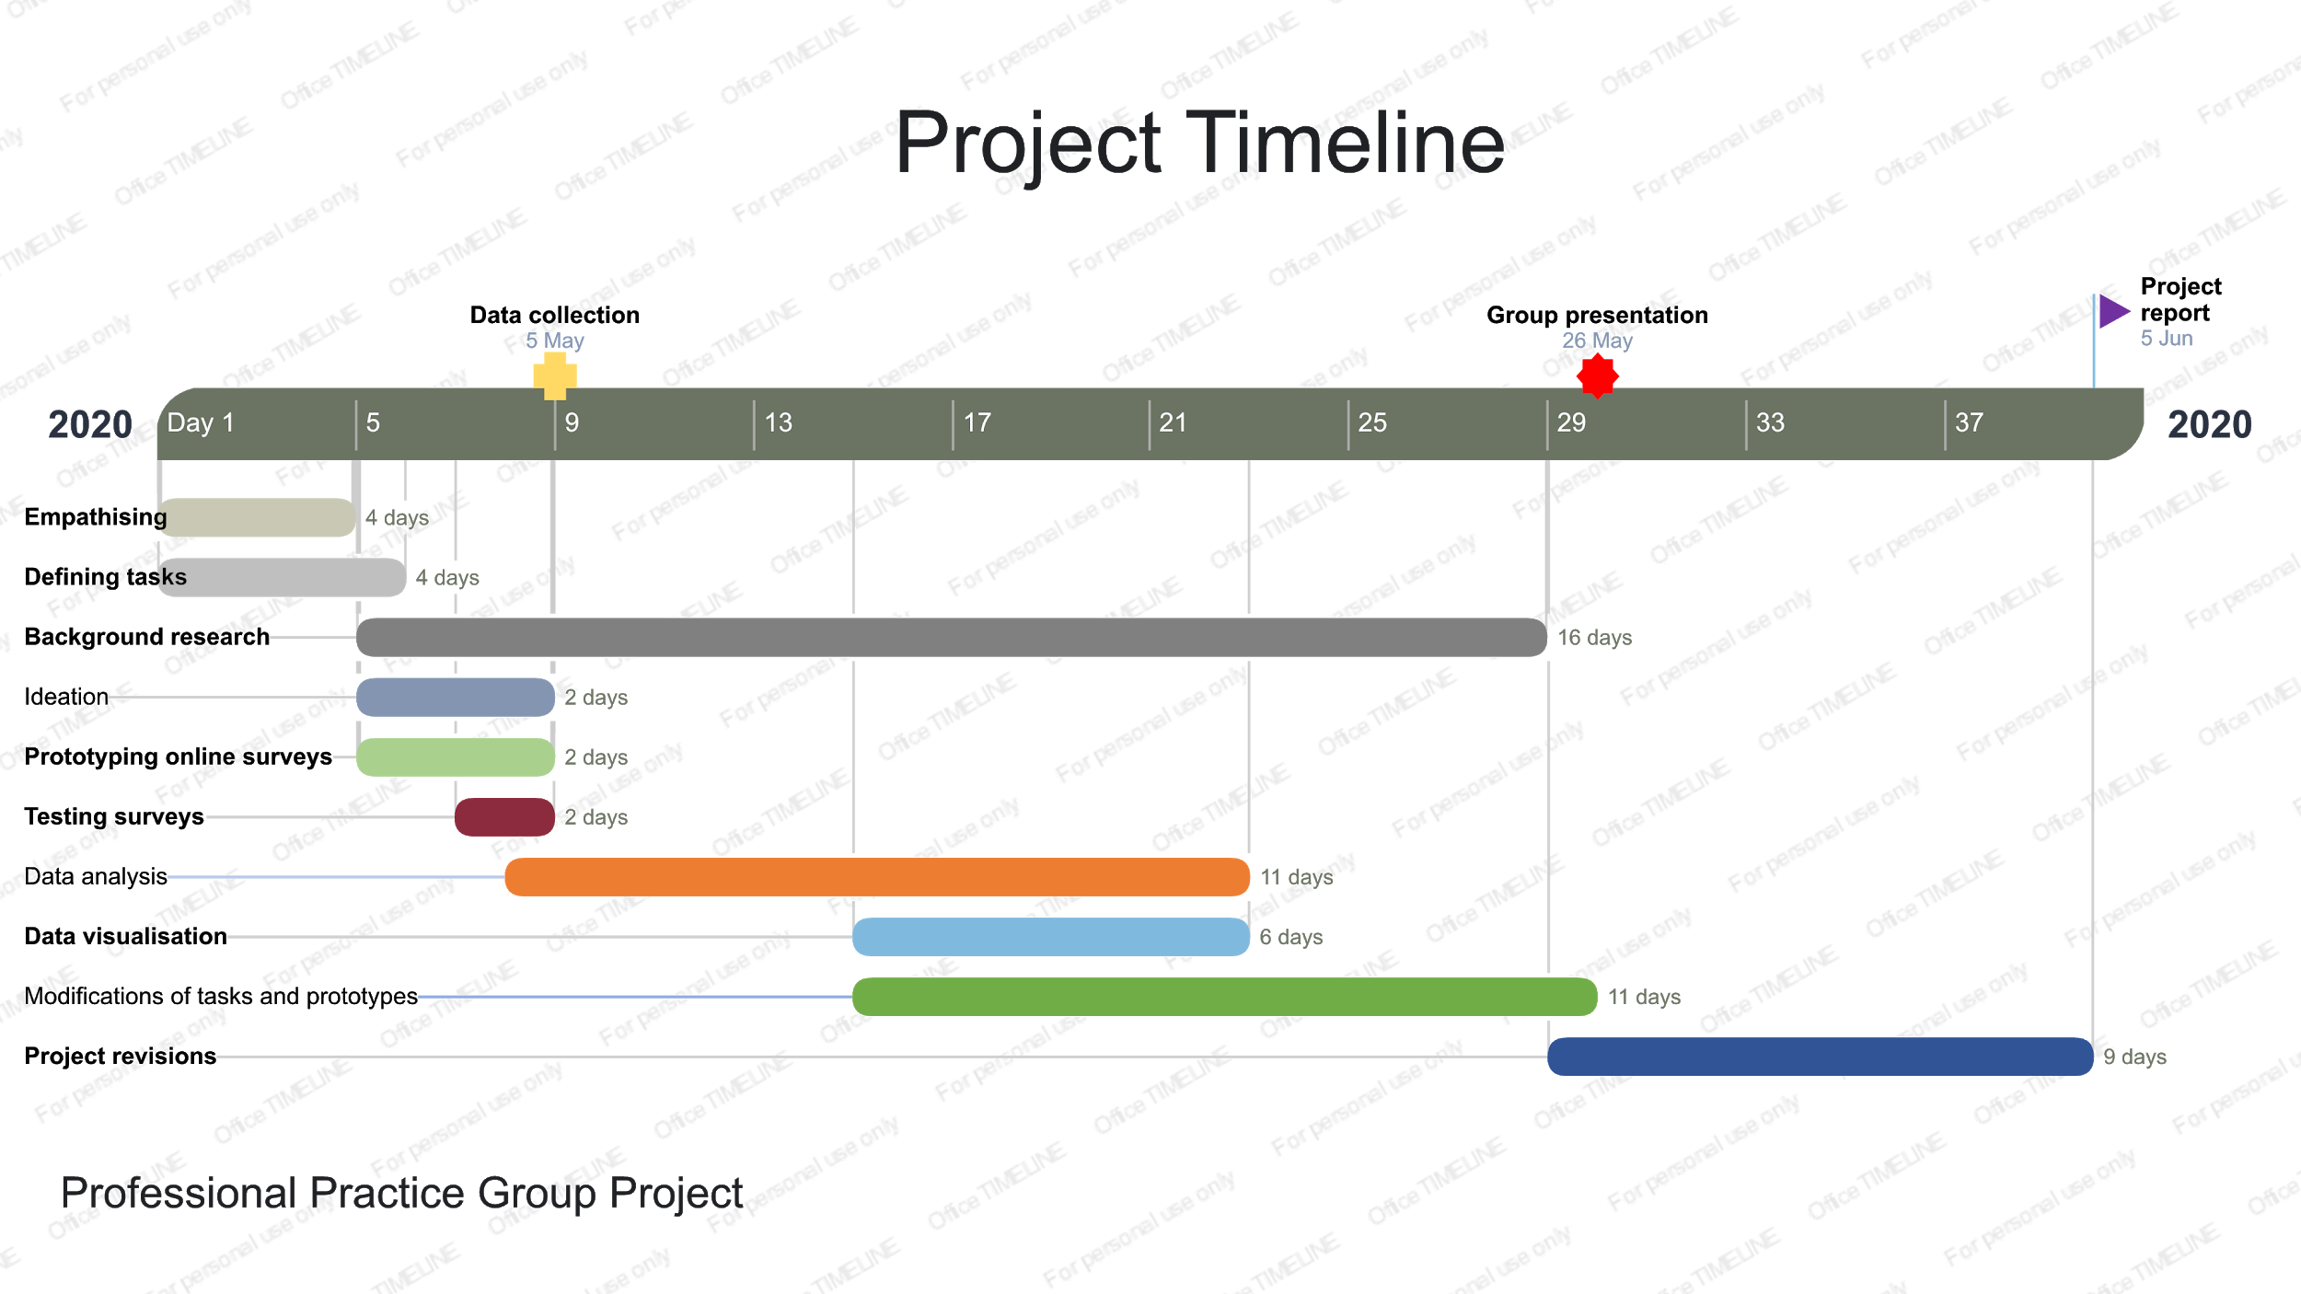

Figure 1. Project timeline

# **4.** **Research Methodology**

## **4.1** **Design Thinking**

Design Thinking (DT) is essentially an iterative and non-linear process aimed at understanding users, challenging assumptions, redefining problems and creating innovative solutions to prototype and testing(). DT is a way of thinking about problems and also a method for working by utilizing a collection of different approaches. Typically, DT consists of five stages including empathize, define, ideate, prototype and test. When tackling ill-defined or unknown problems, we can explore our options more efficiently by applying DT in our workflow().

## **4.2** **Empathising with the user**

Empathize is the first step in our DT process which allows us to attain empathetic understandings of the challenges we are facing. Gaining empathy prepares us by setting aside our previous assumptions and obtaining insights to the problems we are trying to solve. In this project, we proceed the empathy step by designing the survey questions surrounding the three main aspects ACT residents care about and give the feedback on the discussion phase, which are the locations, speed and user limitations.

### **4.2.1** **Research Method**

The primary research is based on the data collection process which provides us with first-hand user data. More specifically, the project follows a five-step DT method. For the empathize step, we take advantage of Google online survey by incorporating both quantitative and qualitative questions to get people’s views on what they care about. The insights from ACT residents provide us with first-hand user data. In the define step, we incorporate it with visualizing and analyzing data to get the basic framework on problems we need to solve. Furthermore, we combine the data results with background and literature review on similar cases both nationwide and worldwide to ideate and come up with reasonable recommendations. The test is further needed for our prototypes. (Suggest replaced by this para)

### **4.2.2** **Data collection**

Our sample comprises seventeen residents in Canberra who are from Professional Practice 1 class. We collect data using the google survey on 05 May 2020. Our initial sample includes seventeen survey feedback, due to the incomplete of the major questions, but we eliminate the two invalid samples. Therefore, our final sample consists of fifteen feedbacks on the ten questions surrounding the views on where e-scooters can travel on, the maximum speed and the restrictions should apply on users.

More specifically, we gather our data on three main aspects:

1. How are we going to ensure e-scooters safety on the road (maximum speed, safety equipment, safety distance, etc.,)?

2. Where can we use e-scooters (proper road areas and parking spots, public transport, etc.,)?

3. Who can have access to e-scooters (age limit for children, license requirement, etc.,)?

A copy of the survey is provided in the Appendix C with the link.

## **4.3** **Recommended Improvements**

In our research, our group makes efforts to apply the DT methods in our workflow to work out the solutions to this project. We empathize with users on acquiring their real needs to amend the ACT laws for e-scooters to ride safely on road. Then we move on to define our tasks based on our observations in a human-centered manner. Next, our group begins to challenge assumptions and generate ideas in the stage of ideating by thinking out of the box. Afterwards, we start to identify the most reasonable solutions for our tasks and come up with scaled-down plans as prototypes. Finally, we test our solutions out in the real situations together with solid background research. After testing, we spot several factors that need improvement in our project. Therefore, we go back to the stage of defining and expressing our tasks more clearly and concretely. Meanwhile, we ideate more relevant ideas as well as modify our prototype plans to adapt to the newly emerged situations. The whole process is an iterative learning process that is extremely efficient in tackling challenging complicated tasks.

However, we did encounter several obstacles during the whole procedure. First, our targeted users are limited to university students. We need to reach out to a broader range of users in ACT to get a more comprehensive and objective view on amending related road laws. Second, our valid survey quantity is insufficient to conclude a statistically authentic suggestion. Due to the limited number of valid surveys, our research may have biased results and this could lead to the decrease in reliability. We ought to address this issue by extending our surveys to more users in the follow up research. Last but not least, we lack the first hand research on the e-scooter market in ACT. This is partly due to the side effect of the Coronavirus lockdown in ACT that limits relevant e-scooter retailers to open up their stores for customers. The real user market can provide us with valuable background information about the real situations about e-scooters on the road. In the future, we should conduct more ground work to get more insights if we have the chance.

# **5.** **Results**

**5.1** **Presentation of Results**

**Maximum speed:**

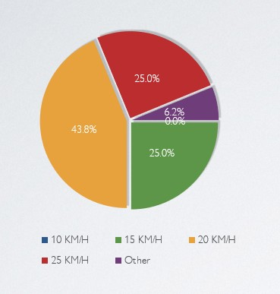

Figure 2. What do you think the maximum speed limit for e-scooters and similar devices should be?

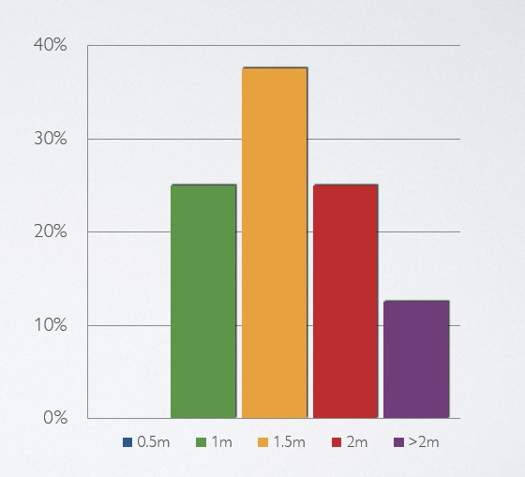

Figure 3. What is the minimum distance between e-scooters on the road?

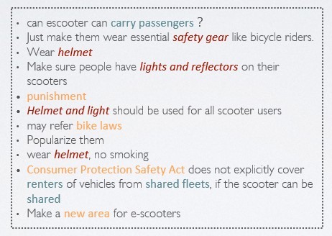

Figure 4. Could you give us any suggestions on how to regulate the e-scooter?

**Road areas:**

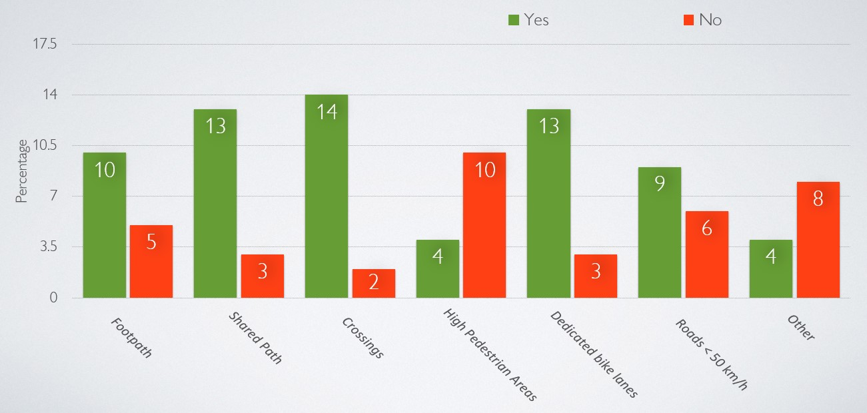

Figure 5. Where do you think e-scooters and similar devices should be able to be ridden on?

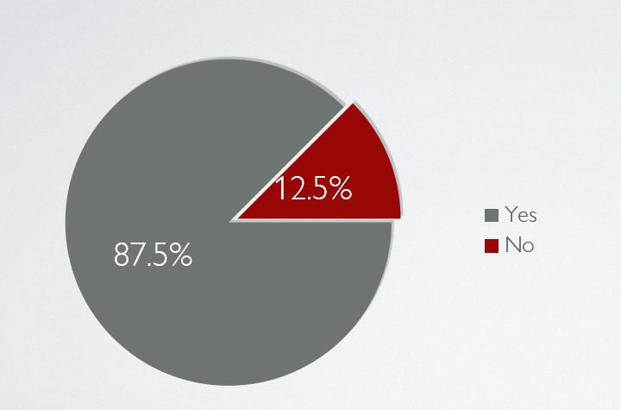

Figure 6. Should these devices be allowed on public transport?

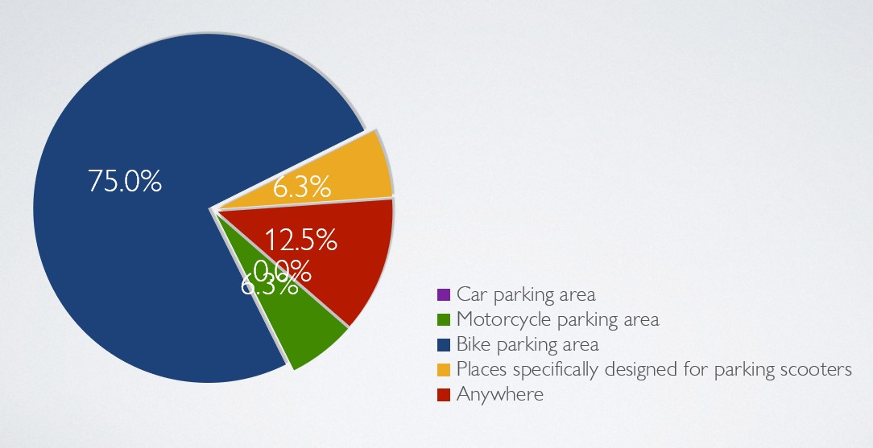

Figure 7. Where should e-scooters be parked?

**Limitations:**

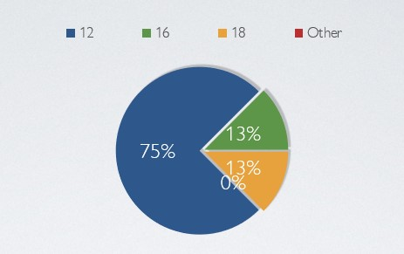

Figure 8. What do you think is a safe age for children to ride unsupervised in a public place?

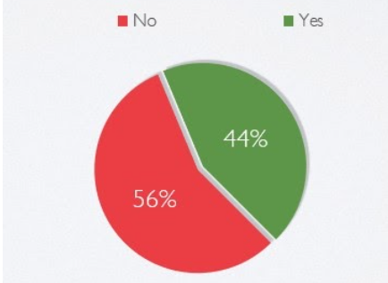

Figure 9. Do you reckon that people are required to hold a license to ride e-scooters?

**Other aspects:**

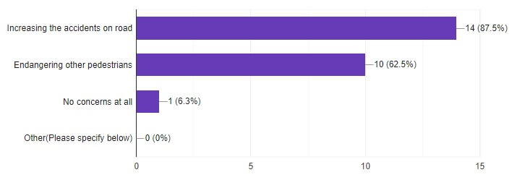

Figure 10. What concerns do you have about introducing e-scooters on the road?

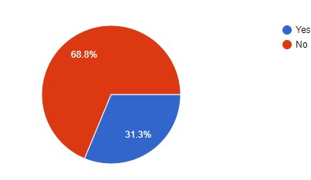

Figure 11. Have you had experience of riding any kind of e-scooters?

# **6.** **Making sense of the data**

**6.1 Maximum speed**

**6.1.1 The maximum speed**

Speed is the biggest factor involved in road deaths, contributing to around 40 per cent of road fatalities each year. No matter how small the devices are, they can become powerful enough to hurt or kill people when they reach high speed. As a result of this, maximum speed limitation is necessary for e-scooter. Limiting the maximum speed that e-scooters can drive is not only for keeping others safe, but also for decreasing the possibility of injuring drivers themselves. On the one hand, the actual and potential risks on the road are not always being obvious or recognisable. On the other hand, a driver’s inability to judge vehicle capabilities, for example stopping, and to adequately anticipate roadway geometry and roadside conditions to determine appropriate driving speeds. As a result, we need speed limits to guard drivers’ safety on the road. There are mainly two elements considered about how fast e-scooters should be.

The first is stopping distance. If something unavoidable appears in front of the e-scooter driver. Whether he or she can stop before a collision depends on the stopping distance. It’s a function related to brakes. Therefore, we get some data about recent products in table 3. From it, we have the average decelerating ability.

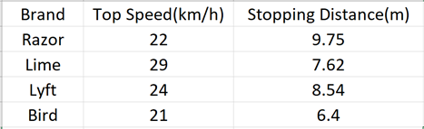

Table 3. Recent e-scooters data

Combining human vision ability and most road situations, 8 meters might be a reasonable stopping distance. Finally, the maximum speed can be detected by following equation, S=V*T-1/2at^2. S is stopping distance, V is maximum speed, T is deceleration time and a is deceleration. Finally, 20 kilometre per hour seems to be a safe maximum speed.

The second factor is relative velocity. Too slow or too fast is equally dangerous for vehicles. Because e-scooters usually share roads with bikes and pedestrians, we need to think over them to get a reasonable speed limitation.

According to statistical results about maximum speed from the survey, shown in the figure 2. 43.8 percent of people choose 20 kilometres per hour. 25 percent of respondents thought 25 kilometres per hour most reasonable is the same as those who vote 15 kilometres per hour.

**6.1.2 Helmet**

In 2018, at least 1545 accidents involving e-scooters happened in the US. The majority of fatalities in accidents related to bicycles and motorcycles are because of injuries to the head. Obviously, it is equally important for e-scooters. By wearing a helmet (2020), if we were ever to be involved in a motorcycle or bicycle accident, it can reduce the severity of the head injury because of the accident. While wearing a helmet does not only completely prevent a head injury, if you have a helmet on, it will provide a cushion for the blow. Wearing a helmet on e-scooters can also help our vision as well by providing protection from the sun's rays or the rain or snow.

**6.1.3 The minimum distance**

The more distance people keep, the more time they get to make a reaction in the accident and avoid others. Working as an important role, the minimum distance between e-scooters and others can also make people feel comfortable. People always are nervous when there are objects with high speed close to them, especially for pedestrians. Then the importance of the minimum distance limitation is obvious.

**6.2 Appropriate areas**

**6.2.1 Appropriate areas for e-scooters to ride on**

Now, let's discuss the survey questions which related to where. According to figure 5 in section 5, it showed that where Canberrans think e-scooter should be allowed. There were 6 most possible places to ride the e-scooter in our survey options. All the locations Canberrans seem that it should be allowed except high pedestrian areas. Over 70 percent of responses agree to prohibit e-scooter on high pedestrian areas. We are not surprised with this result. People might think there will be serious safety concerns for pedestrians if e-scooter be ridden in this area.

**6.2.2 Parking**

After talking about where to ride, where to park might be the next issues to discuss. Regulating the parking area will make the city look tidier and ensure other transportation’s safety. Refer to figure 7 in section 5, 75% people think that bike parking places will be the most suitable spot for placing the e-scooter.

**6.2.3 Public transport allowed?**

Furthermore, people might want to carry an e-scooter on public transport if their destination is far away. Therefore, we also want to know whether Canberrans agree the devices be on public transport. Figure 6 represents that 87.5 percent of our responses think that it is acceptable for e-scooter being on public transport.

**6.2.4 Other cities’ cases**

Let us also look at other city’s relevant rules for e-scooter. Referring to Portland Bureau of Transpiration’s website (2020) , e-scooter were prohibited on sidewalks, crosswalks, and the park. E-scooter cannot be carried on public transport. These rules in Portland are different with our survey result. However, the rule set by the Queensland government is similar to our result. Caldwell (2018) have stated that devices are prohibited on Brisbane CBD roads. The rules might be set to take care about the safety of pedestrians. Furthermore, there is no specific restriction about carrying the devices on public transportation in Queensland. Different cities have different situations and different rules. In part 9, we would talk more about how we think that will be the best for Canberra.

**6.3 Limitations**

**6.3.1 Age limit for children**

According to our survey, the majority of responses (75%) think that it's safe enough for children over 12 years old to ride e-scooters unsupervised on the road. This is a quite understandable response considering the facts that e-scooters and normal scooters share a lot in common in terms of riding experience and steering techniques. Only 12.5% of responses maintain that children must be over 16 to ride independently on the road, while the remaining 12.8% think children should be 18 or older.

However, in other states in Australia where e-scooters have already been legalized on the road, regulations have different rules on the age limit for children. Take Queensland (2020) for example(), road transportation authority limits the children aging from 12 to 16 under adult supervision when they use electric transportation devices such as e-scooters on the road. In South Australia’s trial run of e-scooters (2020), users must be 18 or older to use relevant devices on the road.

**6.3.2 Driver licence requirement**

Driver licence requirement

In our survey, responses divide into two opposite points of view. 56% of responses insist that people do not have to acquire a licence to ride e-scooters on the road, while the other 44% think otherwise. This is a grey area in many other states as it is yet to be regulated by the law enforcement. Only Victoria (Abc.net.au. 2020) has adjusted laws to cover cases for licence requirement on motorised scooters. According to related laws, motorised scooters classified as motor vehicles must be registered, and riders have to get a valid motorcycle licence to ride in public places.

# **7.** **Conclusions and Recommendations**

## **7.1** **Ideating Solutions to the Project Challenge**

Regarding the relative e-scooters data analysis, road shared objects and the survey result analysis, our recommendation of maximum speed is 20 kilometre per hour. Since people can get enough time to avoid obstacles and vehicles. The e-scooters are able to make sure with a short stopping distance. The difference with other objects’ speed is acceptable. E-scooter drivers are suggested to wear helmets and keep 1.5 metres away from others. The reflector should be attached on devices to make other drivers aware of them easily. The government is better to establish a new area for e-scooters to drive and park.

Considering other cases and the data from our survey..E-scooter should not be allowed to travel in the high pedestrian area. Both the survey result and other cities' cases showed that a high pedestrian area is not a safe place for riding the e-scooter. Beside high pedestrian areas, some high accidents or specific areas such as park, crossing, sidewalk, also need to be considered more and set some relevant rules to protect everyone’s safety. Carrying the devices on public transports should be allowed, but riders need to hold tight the e-scooter and keep 1 meter away from other passengers to ensure others safety when the public transport is moving. McMahon's (2018) said that Queensland does not strictly regulate the e-scooter parking place but need to park it “safe and responsible”. We think a bike place might be the most suitable place for parking the e-scooter. But the government will need to set more bike parking places to ensure both bicycles and e-scooter have enough places to park their vehicles. Government might also set the penalty for the rider who does not follow the rule.

At the moment, the ACT government has not regulated laws on who can have access to personal mobility devices including e-scooters. Instead, the ACT listens for the suggestions of manufacturers on who can use the electric devices on the road. Combining the current situation with our survey, we suggest that the government can start a trial run for children above 16 to ride unsupervised on the road to get the preliminary feedback. Depending on the results, the ACT government can adjust the laws accordingly in the future.

As far as the licence is concerned, the only data from our survey is not strong enough evidence on which to base our suggestions. On the other hand, the ACT government should conduct more research on this subject as licence on e-scooters is a controversial issue nationwide in terms of limiting users on the road.

## **7.2** **Responsible Research and Innovation**

The road safety relates to every citizen. Working as a new transportation method, e-scooter is very environmentally friendly and convenient. Especially for those who live in the big city, e-scooter can help them avoid the traffic jam. We should keep people’s right to use e-scooter, meanwhile we need to set limitations on e-scooters for the public safety. According to the properties of e-scooter, we come up with a series of recommendations as above. The standard will decrease the possibility of physical danger and mental worries. Under these limitations, people will enjoy the benefits of e-scooter without conflicts in the future.

# 

# **References**

Abc.net.au. 2020. *How Fast Can E-Scooters Go, And Where Are You Allowed To Ride Them?*. [online] Available at: <https://www.abc.net.au/news/2018-12-23/the-rules-around-scooter-sharing-in-australia/10639170> [Accessed 4 June 2020].

Brown, T., Wyatt, J. & World Bank 2010, *Design Thinking for Social Innovation*.

Buckley, J., 2019. *E-scooters suddenly appeared everywhere, but now they’re riding into serious trouble.* [online] Available at: <https://edition.cnn.com/travel/article/electric-scooter-bans-world/index.html>

Caldwell, F., 2020. *Footpath Scooters Here To Stay, But Not Without New Fines For Misuse*. [online] Brisbane Times. Available at: <https://www.brisbanetimes.com.au/politics/queensland/footpath-scooters-here-to-stay-but-not-without-new-fines-for-misuse-20181213-p50m4t.html> [Accessed 4 June 2020].

Mylicence.sa.gov.au. 2020. *My Licence - Rules For Riding Motorised Scooters And Skateboards In South Australia*. [online] Available at: <https://mylicence.sa.gov.au/road-rules/riding_motorised_scooters> [Accessed 4 June 2020].

Portlandoregon.gov. 2020. *Laws Applicable To Electric Scooters In Portland | Shared Electric Scooter Pilot | The City Of Portland, Oregon*. [online] Available at: <https://www.portlandoregon.gov/transportation/article/689878> [Accessed 4 June 2020].

Personalinjury-law.com. 2020. *The Importance Of Wearing A Helmet | Www.Personalinjury-Law.Com*. [online] Available at: <https://www.personalinjury-law.com/auto-accidents/helmet> [Accessed 4 June 2020].

Qld.gov.au. 2020. *Rules For Personal Mobility Devices*. [online] Available at: <https://www.qld.gov.au/transport/safety/rules/wheeled-devices/personal-mobility-devices> [Accessed 4 June 2020].

Rubin, K., 2013. *Essential Scrum*. Upper Saddle River, NJ: Addison-Wesley.

Schwaber, K. 1997. SCRUM Development Process. *Business Object Design and Implementation*, 117–134. http://doi.org/10.1007/978-1-4471-0947-1_11

The Fast Lane Car. 2020. *Tflscooter: Which Is The Best E-Scooter And Are They Safe? [Video] - The Fast Lane Car*. [online] Available at: <https://www.tflcar.com/2018/11/e-scooter-comparison-video/> [Accessed 4 June 2020].

The Interaction Design Foundation. 2020. *What Is Design Thinking?*. [online] Available at: <https://www.interaction-design.org/literature/topics/design-thinking> [Accessed 4 June 2020]

Vicroads.vic.gov.au. 2020. *Scooters & Wheeled Recreational Devices : Vicroads*. [online] Available at: <https://www.vicroads.vic.gov.au/safety-and-road-rules/road-rules/a-to-z-of-road-rules/scooters-and-wheeled-recreational-devices> [Accessed 4 June 2020].

# 

# **Appendix A Team Effectiveness Survey**

|  |  |  |  |  |  |
| --- | --- | --- | --- | --- | --- |
| Team Name: Group 2A |  |  |  |  |  |
| Tutorial Group T02 / Team Group 2A |  |  |  |  |  |
|  | **SD** | **D** | **U** | **A** | **SA** |
| **Sense of Purpose and Commitment** |  |  |  |  |  |
| 1. We have a clear understanding of our goals |  |  |  |  | x |
| 2. We know our priorities |  |  |  |  | x |
| 3. All team members are committed to our goals |  |  |  |  | x |
|  |  |  |  |  |  |
| **Team Processes** |  |  |  |  |  |
| 4. We have effective communication processes |  |  |  |  | x |
| 5. We have effective problem solving processes |  |  |  | x |  |
| 6. We have effective decision making processes |  |  |  |  | x |
| 7. We have efficient individual accountability processes |  |  |  | x |  |
|  |  |  |  |  |  |
| **Performance Processes** |  |  |  |  |  |
| 8. We have effective processes for tracking individual performance |  |  |  | x |  |
| 9. We have effective processes for rewarding good work |  |  | x |  |  |
|  |  |  |  |  |  |
| **Team Members** |  |  |  |  |  |
| 10. Team members respect and listen to each other |  |  |  |  | x |
| 11. Team members deal with conflict constructively |  |  |  |  | x |
| 12. Team members actively participate in managing our project |  |  |  |  | x |
|  |  |  |  |  |  |
| **Creativity** |  |  |  |  |  |
| 13. We encourage divergent ideas |  |  |  | x |  |
| 14. We utilise the creative talents of individual members |  |  |  |  | x |
| 15. We brainstorm ideas together |  |  |  |  | x |
|  |  |  |  |  |  |
| **Interpersonal Relationships** |  |  |  |  |  |
| 16. I trust the members of my team |  |  |  |  | x |
| 17. We are supportive of each other |  |  |  |  | x |
| 18. Team members contribute equally |  |  |  |  | x |
| 19. We are a cohesive team |  |  |  |  | x |
|  |  |  |  |  |  |
| **Overall Effectiveness** |  |  |  |  |  |
| 20. Team grades have not suffered due to poor teamwork |  |  |  |  | x |

|  |  |  |
| --- | --- | --- |
| **Key** | | |
| **SD** |  | Strongly Disagree |
| **D** |  | Disagree |
| **U** |  | Uncertain |
| **A** |  | Agree |
| **SA** |  | Strongly Agree |

Team Effectiveness Evaluation

*Assess yourself and your team members’ contribution to the achievement and completion of the professional project. Complete only the fields needed to represent the number of people in your team.*

|  |  |  |  |  |  |
| --- | --- | --- | --- | --- | --- |
| **Name and ANU Id of Team Member:** | **HD** | **D** | **CR** | **P** | **F** |
| 1. Lili Chen | x |  |  |  |  |
| 2. Sen Ma | x |  |  |  |  |
| 3. Tian Wu | x |  |  |  |  |
| 4. Yen Kuo | x |  |  |  |  |
|  |  |  |  |  |  |
| **Member** | **Self** | **2** | **3** | **4** | **5** |
| **Contribution to professional project team outcomes** | **Percentage ( % ) of contribution (total 100%)** | | | | |
| Group Pitch | 25 | 25 | 25 | 25 |  |
| Project Report | 25 | 25 | 25 | 25 |  |
| Meeting Minutes | 50 |  |  | 50 |  |

# **Appendix B Meeting Minutes**



# 

# **Appendix C**

*Add additional appendices here. Appendices are not included in the word count. One appendix per page or section. Appendices are labelled alphabetically.*

1. A screenshot of our online survey about e-scooter survey. The survey link is as follows: <https://docs.google.com/forms/d/1Dao2ZmU3ri0YS397nT9r3SfldfXDKz8lqZkIjw1WrLs>

